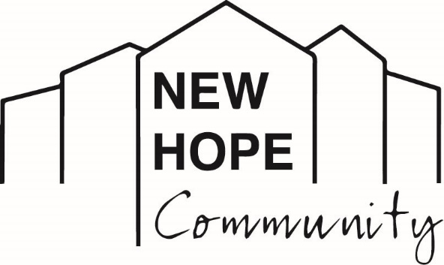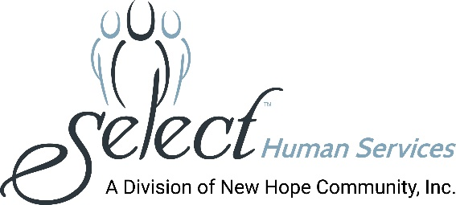
Media Contact: Melissa Rose Marketing Works PR 631.882.7938 melissa@marketingworkspr.com

New Hope Community Celebrates Disability Pride Month
Making Strides in Inclusion and Independence

(LOCK SHELDRAKE, NY - July 21, 2021): July marks “Disability Pride Month” and the staff and people of New Hope Community in Loch Sheldrake, NY joined in celebrating the movement to increase awareness and normalize conversations about disabilities. According to the Center for Disease Control, one in four Americans have some form of disability, far more than you might expect.

A leading human services organization providing supports for individuals with intellectual and other developmental disabilities, New Hope Community offers a variety of hands-on educational, therapeutic and recreational programs, including a wide range of activities at Hope Farm and the Stables at McCoy Meadow.

Photo Caption [Action Trackchair]: Jay joins Anthony and Carly in the fields, using an adaptive Action Trackchair to get around at Hope Farm, a 3-acre working organic farm.
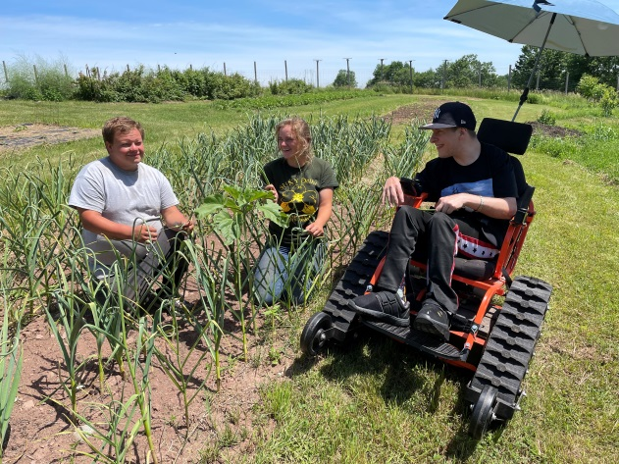
Photo Caption [THRIP Program]: New Hope Community’s Therapeutic Horseback Riding/In-House Program (THRIP) provides equine and other animal therapies where people learn to care for animals and perform essential tasks, and learn different responsibilities.
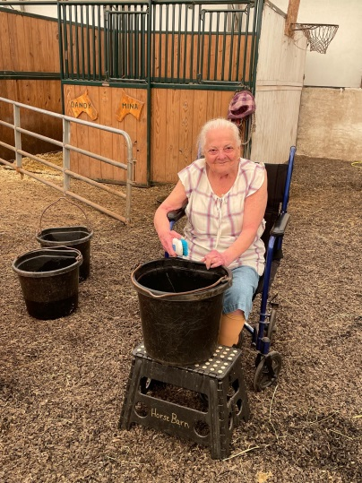
Photo Caption [horse riding]: Riding horses helps build endurance, fosters confidence, and increases physical activity.
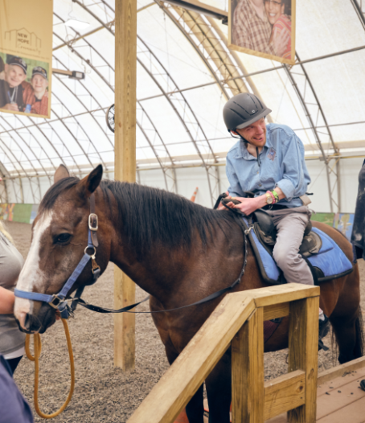
About New Hope Community
New Hope Community is a not-for-profit human services organization providing supports for individuals with intellectual and other developmental disabilities. Established in 1975 to serve as a nurturing and caring alternative to large institutions which were found to have violated the most basic human rights and conditions, New Hope Community has become recognized as a leading provider in the human services field. In January 2020, New Hope Community merged with Select Human Services, Inc. (SHS) of Pleasantville, NY, a not-for-profit voluntary agency providing services in Westchester, Putnam, and Rockland Counties. New Hope Community’s breadth of services includes clinical and nursing care, residential services, day programming, community habilitation, self-direction, support brokers, service navigators, education, recreation and leisure activities, a robust supported employment program, summer programs for youths, and so much more. New Hope Community has always maintained a person-centered approach toward enhancing the lives of people with disabilities and actively advocates for individual choice in a person’s efforts to live, work and participate fully in his or her community. New Hope Community and SHS, combined, provide services to over 700 people and employ more than 1,000 staff.
###

