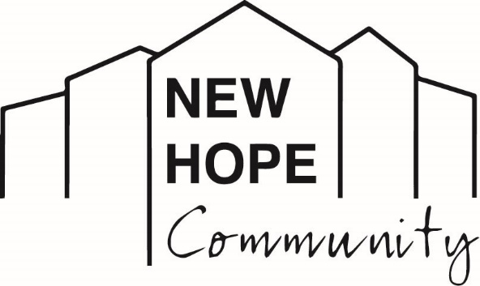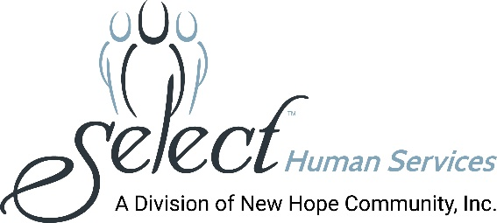

Media Contact: Melissa Rose Marketing Works PR 631.882.7938 melissa@marketingworkspr.com

BOCES Superintendent Robert M. Dufour Is Elected to
Board of Directors of New Hope Community

(LOCK SHELDRAKE, NY - August 13, 2021): New Hope Community is pleased to announce that Robert M. Dufour, Ed.D., District Superintendent/Chief Executive Officer of Sullivan BOCES in Liberty, NY, has been appointed to serve as a member of the Board of Directors. New Hope Community is a not-for-profit organization providing person-centered services and supports for people with intellectual and other developmental disabilities.

“We welcome Dr. Dufour to our leadership team and look forward to the knowledge and insights he brings as an accomplished educator and advocate. His expertise in developing regional partnerships will help us further empower the men and women we support and strengthen our community,” said Board Chair, Juliette P. McKerrell.

Dr. Dufour, who resides in Pond Eddy, NY, has worked in Sullivan County for the past 20 years and is committed to academic excellence and the provision of positive educational experiences for local students. Before joining BOCES, he served for seven years as the Superintendent of Schools at the Eldred Central School District in NY.

He is a Board Member of the Sullivan County Chamber of Commerce, and is a member of the Sullivan County Rural Health Network and the Sullivan County Opioid Task Force. He also serves on the community advisory board for Sullivan 180, a regional partnership for healthier lifestyles, and on the Board of Directors of the Sullivan County Broadband Local Development Corporation, which strives for greater internet accessibility.

PHOTO CAPTION: Robert M. Dufour, Ed.D., District Superintendent & Chief Executive Officer, Sullivan BOCES. CREDIT: Picture This Studios in Fishkill, NY

About New Hope Community
New Hope Community is a not-for-profit human services organization providing supports for individuals with intellectual and other developmental disabilities. Established in 1975 to serve as a nurturing and caring alternative to large institutions which were found to have violated the most basic human rights and conditions, New Hope Community has become recognized as a leading provider in the human services field. In January 2020, New Hope Community merged with Select Human Services, Inc. (SHS) of Pleasantville, NY, a not-for-profit voluntary agency providing services in Westchester, Putnam, and Rockland Counties. New Hope Community’s breadth of services includes clinical and nursing care, residential services, day programming, community habilitation, self-direction, support brokers, service navigators, education, recreation and leisure activities, a robust supported employment program, summer programs for youths, and so much more. New Hope Community has always maintained a person-centered approach toward enhancing the lives of people with disabilities and actively advocates for individual choice in a person’s efforts to live, work and participate fully in his or her community. New Hope Community and SHS, combined, provide services to over 700 people and employ more than 1,000 staff.
###

