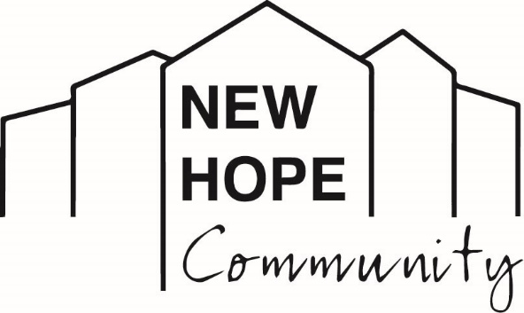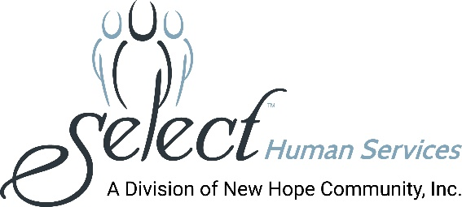
Media Contact: Melissa Rose Marketing Works PR 631.882.7938 melissa@marketingworkspr.com

New Hope Community’s Erin Rion Appears on Jeopardy,
Staff Member’s Knowledge and Poise Clinch Second Place

(LOCK SHELDRAKE, NY - August 2, 2021): Erin Rion, of Napanoch, NY, appeared on national television recently as a contestant on the popular game show, “Jeopardy,” much to the delight of her friends, family, co-workers and the people with developmental disabilities whom she supports at New Hope Community.

Rion is the director of clinical services at New Hope Community, a leading human services organization supporting men and women who have intellectual and developmental disabilities located in Loch Sheldrake, NY. Always a veracious reader – who as a young adult would read a book a day -- she seized the opportunity to try out for the show over a year ago.

During the show’s airing on June 15th, Rion joined fellow guests in introducing herself with a fun fact, revealing to the show’s Guest Host, Savannah Guthrie, that she has long had “glitter phobia.” The fear stemmed from a warning given by a kindergarten teacher who once said that if glitter got in your eyes it could blind you! Laughing it off and looking back on the experience, she recalled, “My Jeopardy experience was wonderful, and Savannah was so kind and so professional. She made all of the contestants feel really comfortable.”
“It was also nerve wracking,” she recalled, because due to the COVID-19 pandemic, she could not bring anyone on the trip for moral support. She even had to do her own hair and make-up, and bring her own snacks for the day.

However, when the cameras began to roll, Erin steadily chipped away at several categories showing her extensive knowledge in pop culture, theater, literature and general trivia. She was even the victor of a Daily Double.

Going into Final Jeopardy with a lock on second place, she correctly answered the Final Jeopardy question: “During her second marriage, she split her time among homes in New York, New Jersey, Paris, Greece and a yacht.” Erin gave the correct answer (“Who is Jacqueline Kennedy Onassis?”) but chose to wager zero dollars. Erin was awarded $2,000 as the second-place finisher and received many hearty congratulations on her appearance.

“We are so proud of Erin for following her dreams and doing so well on the show. She is certainly a winner here at New Hope Community and it was a thrill for all of us to cheer her on!” said Debra McGinness, Chief Executive Officer, New Hope Community.

“The hardest part was the buzzer,” she explained. “You only have a split second to ring in, and if you ring in too early, you get locked out. It's much harder than it looks on TV!”

Among the highlights of the experience, she adds, was meeting and spending time with all the other contestants. It is an accomplishment she can check off her bucket list and savor for years to come.
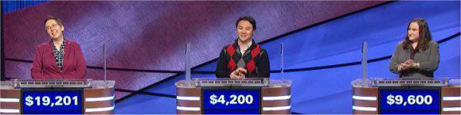

Pictured, far right: Erin Rion, who works with people with intellectual and developmental disabilities at New Hope Community in Loch Sheldrake, cheers on her fellow contestants during a recent appearance on Jeopardy.

About New Hope Community
New Hope Community is a not-for-profit human services organization providing supports for individuals with intellectual and other developmental disabilities. Established in 1975 to serve as a nurturing and caring alternative to large institutions which were found to have violated the most basic human rights and conditions, New Hope Community has become recognized as a leading provider in the human services field. In January 2020, New Hope Community merged with Select Human Services, Inc. (SHS) of Pleasantville, NY, a not-for-profit voluntary agency providing services in Westchester, Putnam, and Rockland Counties. New Hope Community’s breadth of services includes clinical and nursing care, residential services, day programming, community habilitation, self-direction, support brokers, service navigators, education, recreation and leisure activities, a robust supported employment program, summer programs for youths, and so much more. New Hope Community has always maintained a person-centered approach toward enhancing the lives of people with disabilities and actively advocates for individual choice in a person’s efforts to live, work and participate fully in his or her community. New Hope Community and SHS, combined, provide services to over 700 people and employ more than 1,000 staff.
###

