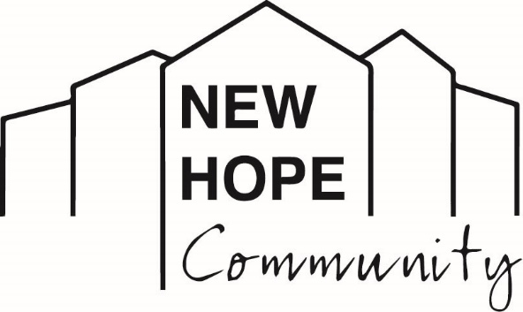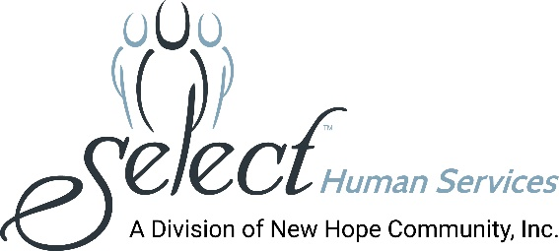
Media Contact: Melissa Rose Marketing Works PR 631.882.7938 melissa@marketingworkspr.com

SUNY Sullivan Nursing Students Gain Practical Insights
Through On-Site Experience at New Hope Community

(LOCK SHELDRAKE, NY - June 23, 2021): New Hope Community, in Loch Sheldrake, NY, is forging forward with a collaborative partnership with SUNY Sullivan to provide nursing students with an invaluable clinical rotation involving the provision of healthcare supports to people with intellectual and developmental disabilities (I/DD). CEO, Debra McGinness, whose career began as a pediatric nurse, extoled the importance of this program, saying “It is critical to equip nursing professionals with a comprehensive understanding of how best to holistically support patients with special needs. Optimal health care experiences can only be realized when all health care professionals understand the nuances and needs of patients with I/DD.”

The weekly program complements students’ academic coursework. “The program has been an excellent experience for the students because it opens their eyes to working with a population whose needs may not be addressed in the typical nursing school curriculum,” said Karen Russell, Chief Operating Officer, New Hope Community. While developmental disabilities affect a small portion of the population – 1 to 3 percent globally -- meeting their needs can be quite complex. “This is an ideal opportunity to change perceptions and to build practical skills that nurses can use throughout their careers,” Russell said.

“The program is innovative and fills a void,” noted Karen Kerendian, RN, Director of Health Services for New Hope Community, “because it brings together the expertise of educators and health professionals working within the I/DD community to prepare students for addressing the physical, social and emotional well-being of people with disabilities.”

The program is an outgrowth of New Hope Community’s partnership with SUNY Sullivan which has included the establishment and operation of a 3-acre organic farm on its campus and enrollment services for individuals with disabilities from New Hope Community in the College for Educational Enrichment Program.

Since signing an agreement in 2019, 65 students have rotated through the clinical rotation program. Students start their day at New Hope Community in a classroom setting with their instructor and are assigned to group residences on the NHC campus where their education continues. The visiting students are encouraged to observe and ask questions of the nursing staff, and residential managers, and shadow the one-on-one direct support professionals, who comprise the New Hope Community team.

“We are excited about the program and are happy to welcome the nursing students and work with them so they are comfortable caring for people who might have different ways of communicating or use adaptive equipment they are not familiar with,” said Kerendian. “We are able to draw on our experience, share some of the tools we use and to be there for them as a resource.”

In addition to ensuring that people with disabilities are approached with respect and understanding, Russell believes the program could open students’ minds toward pursuing careers in disabilities services or similar nursing opportunities.

“We hope this will serve as a model for nursing programs across the country to start gradually closing the awareness gap for intellectual and other developmental disabilities in health care,” Russell concluded.

Photo Caption: Nursing students meet with their clinical instructor at New Hope Community to receive their assignment and goals for the day.

About New Hope Community
New Hope Community is a not-for-profit human services organization providing supports for individuals with intellectual and other developmental disabilities. Established in 1975 to serve as a nurturing and caring alternative to large institutions which were found to have violated the most basic human rights and conditions, New Hope Community has become recognized as a leading provider in the human services field. In January 2020, New Hope Community merged with Select Human Services, Inc. (SHS) of Pleasantville, NY, a not-for-profit voluntary agency providing services in Westchester, Putnam, and Rockland Counties. New Hope Community’s breadth of services includes clinical and nursing care, residential services, day programming, community habilitation, self-direction, support brokers, service navigators, education, recreation and leisure activities, a robust supported employment program, summer programs for youths, and so much more. New Hope Community has always maintained a person-centered approach toward enhancing the lives of people with disabilities and actively advocates for individual choice in a person’s efforts to live, work and participate fully in his or her community. New Hope Community and SHS, combined, provide services to over 700 people and employ more than 1,000 staff.
###

