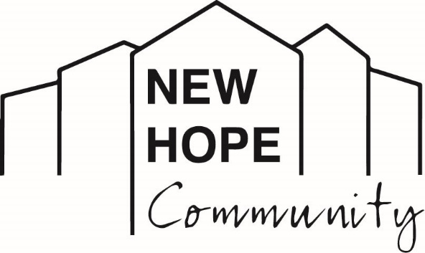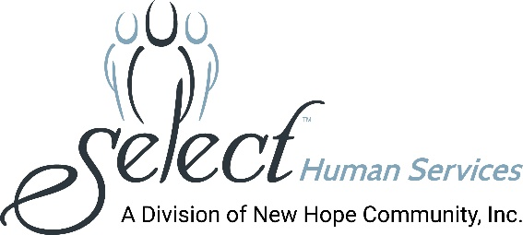
Media Contact: Melissa Rose Marketing Works PR 631.882.7938 melissa@marketingworkspr.com

Sun Shines on 11th Annual Wallace Berkowitz Golf Outing to
Support New Hope Community’s Mission

(LOCK SHELDRAKE, NY – June 14, 2021): A total of 124 golfers teed off on May 17th in support of the organization’s major fundraiser of the year - the Wallace Berkowitz Golf Outing. The foursomes set out on a summer-like day at the beautiful West Hills Golf Club in Middletown, NY, to raise funds for programs that support and empower the lives of men and women with intellectual and developmental disabilities.

At check-in, each golfer received a goody bag and special favor – a Ping putter – courtesy of the event’s Platinum Sponsors, Hudson Regional Long-Term Care Pharmacy and Arthur Gallagher and Company. Additional funding was provided by Event Sponsors: UBS, M&T Bank, Countrywide Autos and Polaris and Sterling National Bank.

Before golfers headed out on the course for a challenging day of golf and camaraderie, they were welcomed by Debra McGinness, Chief Executive Officer, and enjoyed a bagpipe send-off by Tom Burnham, Executive Director of the New Hope Community Foundation. The outing has been held annually for more than a decade, in honor of Wallace Berkowitz, a former New Hope Community Board Member, Sullivan County accountant, and champion for the rights and dignity of people with developmental disabilities.

“This has been a challenging year for all of us but today we have the opportunity to enjoy an amazing day together,” McGinness said. “I want to thank our golfers and generous sponsors for joining us in an event that fuels our ability to build a better world for people with disabilities; a world that realizes and recognizes so many possibilities!”

For more than 46 years, New Hope Community has supported and celebrated the lives of thousands of men and women with disabilities. New Hope provides comprehensive supports and services that include: residential, clinical, nursing, day habilitation, community habilitation, supported employment, and more. Many activities are enjoyed through New Hope Community’s Hope Farm, their equestrian program at McCoy Meadows, and their music, art and recreational offerings.

At the end of the day, golf and raffle winners’ names were posted with a note of appreciation from McGinness. “Thank you to everyone who made this outing possible. Today, we are all winners.” And the winners were:

WINNING TEAM (54)
Ricky Wolbrom, Ryan Sheflott, Tony Riina, Brad Edwards
MEN – CLOSEST TO THE PIN
Dan Hughes 33”
WOMEN – CLOSEST TO THE PIN
No winner
MEN – LONGEST DRIVE
Rick Morgan
WOMEN – LONGEST DRIVE
Angela Carkner
MOST HONEST TEAM (79)
Sandy Goldstein, Leslie Danish, Ken Weigand, Laura Leach
ORANGE BALL WINNERS (59)
Stanley Gilmore, Butch Gilmore, John Bruer, Nick Price
50/50 WINNER
John Bruer
CALLAWAY GOLF SET WINNER
Anne Sweazey

PHOTO CAPTIONS:
Photo 1: Sandy Goldstein, one of many longtime supporters and friends of New Hope Community, supported the popular outing.
Photo 2: The winning foursome sponsored by Lakeland Bank (l to r): Ricky Wolbrom, Ryan Sheflott, Brad Edwards, Tony Riina.
Photo 3: Lucky winners took home raffle prizes.

About New Hope Community
New Hope Community is a not-for-profit human services organization providing supports for individuals with intellectual and other developmental disabilities. Established in 1975 to serve as a nurturing and caring alternative to large institutions which were found to have violated the most basic human rights and conditions, New Hope Community has become recognized as a leading provider in the human services field. In January 2020, New Hope Community merged with Select Human Services, Inc. (SHS) of Pleasantville, NY, a not-for-profit voluntary agency providing services in Westchester, Putnam, and Rockland Counties. New Hope Community’s breadth of services includes clinical and nursing care, residential services, day programming, community habilitation, self-direction, support brokers, service navigators, education, recreation and leisure activities, a robust supported employment program, summer programs for youths, and so much more. New Hope Community has always maintained a person-centered approach toward enhancing the lives of people with disabilities and actively advocates for individual choice in a person’s efforts to live, work and participate fully in his or her community. New Hope Community and SHS, combined, provide services to over 700 people and employ more than 1,000 staff.
###

